A

REPORT ON

“OBSTCLE AVOIDING CAR USING ARDUINO UNO”
Project submitted to the State Board of Technical Education, Hyderabad in partial fulfillment of the requirements for the award of the degree of Diploma in Electronics and Communication Engineering
BY
P. VENKATESH 21290-EC-100
G.SAITEJA 21290-EC-083
K.CHANDRAKANTH 21290-EC-107
M.MADHAV 21290-EC-072
MD.MUJAHID 21290-EC-086
Under the Esteemed Guidance of
T.SRUJANA
Dept. of ECE,SDES

DEPARTMENT OF ELECTRONICS AND COMMUNICATION ENGINEERING
SREE DATTHA INSTITUTE OF ENGINEERING AND SCIENCE
(Accredited by NBA, Approved by AICTE & Affiliated by JNTU, Hyderabad)
Sheriguda, Ibrahimpatnam, Rangareddy-501510.

SREE DATTHA INSTITUTE OF ENGINEERING AND SCIENCE
(Accredited by NBA, Approved by AICTE & Affiliated by JNTU, Hyderabad)
Sheriguda,ibrahimpatnam,Rangareddy-501510.2023-2024
DEPARTMENT OF ELECTRONICS AND COMMUNICATION ENGINEERING

Institute code:290

CERTIFICATE
This is to certify that the project entitled “OBSTACLE AVOIDING CAR USING ARDUINO UNO” submitted in partial fulfillment of the requirements for the degree of Diploma in Electronics and Communication Engineering of State Board of Technical Education, Hyderabad is a bonafide work carried out by P.VENKATESH (21290-EC-100), G.SAITEJA(21290-EC-083),K.CHANDHU(21290-EC-107),M.MADHAV (21290-EC-072), MD.MUJAHID(21290-EC-086).Has done under the guidance and supervision.

INTERNAL GUIDE PROJECT CORDINATOR
Mrs. T.SRUJANA P.VAMSHI

HOD-ECE PRINCIPAL
P.SAHITHI MD.MUKRAMUDDIN


SREE DATTHA INSTITUTE OF ENGINEERING AND SCIENCE
(Accredited by NBA, Approved by AICTE & Affiliated by JNTU, Hyderabad)
Sheriguda,ibrahimpatnam,Rangareddy-501510.2023-2024
DEPARTMENT OF ELECTRONICS AND COMMUNICATION ENGINEERING

ACKNOWLEDGEMENT
We acknowledge and express our gratitude and sincere thanks to our guide Mrs. T.SRUJANA. Of the Department of Electronics and Communication Engineering of State Board of Technical Education, Hyderabad, for her constant supervision and continuous encouragement for the completion of project work through her valuable suggestions and timely supervision. We wish to express our heartfelt appreciation for her valuable guidance.
We also exprees our thankfulness to the HOD,P.SAHITHI Of Electronics and Communication Engineering for her support and encouragement for the completion of the project.
Thanks are also due to the Principal, MD.MUKRAMUDDIN of Electronics and Communication Engineering for the conductive Environment creative by him in the college for effective completion of the project work undertaken by us.
P.VENKATESH 21290-EC-100
G.SAI TEJA 21290-EC-083
K.CHANDRAKANTH 21290-EC-107
M.MADHAV 21290-EC-072
MD.MUJAHID 21290-EC-086


SREE DATTHA INSTITUTE OF ENGINEERING AND SCIENCE
(Accredited by NBA, Approved by AICTE & Affiliated by JNTU, Hyderabad)
Sheriguda,ibrahimpatnam,Rangareddy-501510.2023-2024
DEPARTMENT OF ELECTRONICS AND COMMUNICATION ENGINEERING

DECLARATION
Certified that this bonafide record of the dissertation work entitled “OBSTACLE AVOIDING CAR USING ARDUINO UNO”, is a record work done by us in the Department of Electronics and Communication Engineering, Sree Dattha Institute of Engineering and Science. Has been carried out by us under the internal guide of Mrs. T.SRUJANA. To the best of the knowledge, this work has been not submitted for any other degree in any university.

P.VENKATESH 21290-EC-100
G.SAI TEJA 21290-EC-083
K.CHANDRAKANTH 21290-EC-107
M.MADHAV 21290-EC-072
MD.MUJAHID 21290-EC-086

INDEX
CONTENTS PAGE NO
Abstract I
List of the Figures II
List of Tables IV
Abbreviations V
CHAPTER-1 INTRODUCTION TO EMBEDDED SYSTEM
  - Embedded system 1
1.1.1 Embedded system Features and Application
1.1.2 Features 2
1.1.3 Applications 2
CHAPTER-2 ARDUINO UNO
2.1 ARDUINO UNO 3
2.1.1 Features 3
2.1.2 Description 3
2.1.3 Pin Diagram of (ARDUINO UNO) 4
2.1.4 Pin Description 4
CHAPTER-3 BLOCK DIAGRAM
3.1 Transmitter Section 8
3.2 Receiver Section 8
3.3 Power Supply Block Diagram 9
3.3.1 Circuit Diagram 9

CHAPTER-4 HARDWARE
4.1 Motor Drive shield (L293D) 10
4.2 SG-90 Servo Motor 11
4.3 Ultrasonic sensor 11
4.4 Switch 12
4.5 LI-ON Battery 12
4.6 TT Gear Motor 13
4.7 Jumper wires 13
CHAPTER-5 SOFTWARE
5.1 Software Explanation 14
5.1.1 Set up the software 15
5.2 Code
5.2.1 Installation of code 16
5.2.2 Run the code & Upload the code 17
CHAPTER-6 SCHEMATIC DIAGRAM
6.1 Schematic Diagram 18
6.2 Schematic Diagram Explanation 19
6.3 Working Principle 19
CHAPTER-7 RESULT
7.1 Result 21
CHAPTER-8 ADVANTAGES & APPLICATIONS
8.1 Advantages 22
8.2 Applications 22
CHAPTER-9 CONCLUSION
9.1 Conclusion 23
CHAPTER-10 FUTURE SCOPE 24
APPENDIX 25
REFERENCE 31

ABSTRACT
The aim of the project is to design “OBSTACLE AVOIDING CAR USING ARDUINO UNO”.
This project to create a cost-effective and efficient autonomous vehicle capable of navigating its environment and avoiding obstacle in real-time.
The key components of this project include ultra sonic sensors for distance measurement, a motor control system, and the Arduino Uno processes the sensors enable the car to detect obstacle in its path, while the Arduino Uno processes the sensor data and controls the motors to navigate around the obstacle. This results in a car that can autonomously move forward, backward, turn, and make decisions to avoid collisions.
The development process involves programming the Arduino Uno to interpret the sensor data, calculate distance to obstacles, and determine the optimal path to follow. The car’s motors are controlled through PWM signals generated by the Arduino to achieve smooth and precise movements. To ensure accurate obstacle avoidance, the system uses predefined decision-making algorithms, which allow the car to navigate through complex environment effectively.
In this project the components we use are Arduino Uno, Gear motor, switch, Li-on battery, jumper wire, Ultrasonic sensor, Servo motor, Motor Drive shield.

I
LIST OF FIGURES
Sl.no | Figure no. | Name of the figure | Page no.
1 | 2.1 | Pin diagram of ATmega328P | 4
2 | 3.1 | Transmitter Block Diagram | 8
3 | 3.2 | Receiver Block Diagram | 8
4 | 3.3 | Power Supply Block Diagram | 9
5 | 3.4 | Circuit Diagram | 9
6 | 4.1 | Motor driver shield | 10
7 | 4.2 | Servo Motor | 11
8 | 4.3 | Ultrasonic sensor | 11
9 | 4.4 | Switch | 12
10 | 4.5 | LI-on Battery | 12
11 | 4.6 | TT Gear Motor | 13
12 | 4.7 | Jumper Wire | 13
13 | 5.1 | Arduino UNO | 14
14 | 5.1.1 | Arduino IDE software in windows | 15
15 | 5.1.2 | Arduino IDE project code | 16

ii
16 | 5.1.3 | Program  output | 17
17 | 6.1 | schematic diagram | 18
18 | 7.0 | Obstacle avoidance car using Arduino uno | 21

iii
LIST OF TABLES
Sl. No | Table No | Name of the Table | Page no
1 | 2.1 | Pins | 4

Iv

LIST OF ABBREVATION
S.NO | SHORT FORM | ABBREVATIONS
1  2  3  4  5  6  7  8  9  10  11  12  13  14 | GPS  DC  AC  AI  IDE  IDII  LED  USB  CPU  GND  COM  DIY  PWM  PC | Global positioning system  Direct current  Alternating current  Artificial intelligence  Integrated development environment  Interaction design institute Ivrea  Light emitting diode  Universal serial bus  Central processing unit  Ground  Communication  Do it yourself  Pulse width modulation  Personal computer

V
OBSTACLE AVOIDING CAR USING ARDUINO UNO

CHAPTER-1
1. INTROUDUCTION TO EMBEDDED SYSTEMS
1.1 Embedded System:
An embedded system is a system which is going to do a predefined specified task is the embedded system and is even defined as combination of both software and hardware. A general-purpose definition of embedded system is that they are devices used to control, monitor or assist the operation of equipment, machinery or plant. “Embedded” reflects the fact that they are an integral part of the system. At the other extreme a general-purpose computer may be used to control the operation of a large complex processing plant, and its presence will be obvious.
All embedded systems are including computers or microprocessors. Some of these computers are however very simple systems as compared with the personal computers. The very simple embedded system are capable of performing only a single functions or set of functions to meet a single predetermined purpose. In more complex systems an application program that enables the embedded system to be used for a particular purpose in a specific application determines the functionality of the embedded system. The ability to have programs means that the same embedded system can be used for a variety of different purposes. In some cases, a microprocessor may be designed in such a way that application software for a particular purpose can be added to the basic software in a second process, after which it is not possible to make further changes. The application software on such processors is sometimes referred to as firmware

1

OBSTACLE AVOIDING CAR USING ARDUINO UNO

  - EMBEDDED SYSTEM FEATURES AND APPLICATIONS
    - SPECIAL FEATURES
- Embedded system do a very specific task; they cannot be programmed to do different things. Embedded systems have very limited resources, particularly the memory. Generally, they do not have secondary devices such as the CDROM or the floppy disk.
- Embedded systems are constrained for power. As many embedded systems operate through a battery, the power consumption has to be very low.
- Some embedded systems have to operate in extreme environment conditions such as very high temperatures and humidity.
    - APPLICATIONS:
Nearly 99% of the processors manufactured end up in embedded systems. The embedded system market is one of the highest growth areas as these systems are used in very market segment consumer electronics, office automation, industrial automation, wireless communication, data communication, telecommunication, transportation military and soon.
- Consumer appliances: At home we use a number of embedded systems which include digital camera, digital diary, DVD player, air-conditioner, video game consoles, video recorders etc.
- Office automation: The office automation products using embedded systems are copying machine, printer, scanner, key telephone etc.

2
OBSTACLE AVOIDING CAR USING ARDUINO UNO

CHAPTER-2
ARDUINO UNO
2.1 ARDUINO UNO:
2.1.1 Features:
- The operating voltage is 5v
- The recommended input voltage will range from 7V to 12V
- Digital input/output pins are 14
- Analog I/O pins are 6
- DC Current for each input/output pin is 40 mA
- DC Current for 3.3V pin is 50 mA
- Flash memory is 32 KB
- CLK Speed is 16 MHz
2.1.2 Description:
The Arduino Uno is a popular open-source microcontroller board based on the ATmega328P microcontroller. It has 14 digital input/output pins (of which can be used as PWM outputs), 6 analog inputs, a 16 MHz quartz crystal, a USB connection, a power jack, and a reset button. Arduino Uno is commonly used by hobbyists, students, and professionals to create various electronic projects due to its ease of use and versatility. It can be
programmed using the Arduino software, which allow user to write code and upload it to the board for execution.

3
OBSTACLE AVOIDING CAR USING ARDUINO UNO

2.1.3 Pin Diagram of ARDUINO UNO:
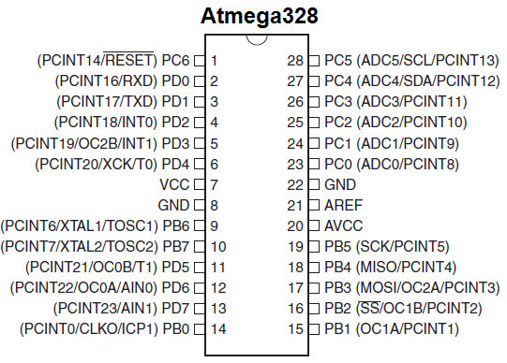Fig2.1pindiagram of ATmega328P
2.1.4 Pin Description:
The table below gives a description for each of the pins, along with their function.
Pin Number | Description | Function
1 | PC6 | Reset
2 | PD0 | Digital Pin (RX)

4
OBSTACLE AVOIDING CAR USING ARDUINO UNO

3 | PD1 | Digital Pin (TX)
4 | PD2 | Digital Pin
5 | PD3 | Digital Pin (PWM)
6 | PD4 | Digital Pin
7 | VCC | Positive Voltage (Power)
8 | GND | Ground
9 | XTAL 1,2 | Crystal Oscillator
10 | PD5 | Digital Pin (PWM)
11 | PD6 | Digital Pin (PWM)
12 | PD7 | Digital Pin
13 | PB0 | Digital Pin
14 | PB1,2,3 | Digital Pin (PWM)
15 | PB4,5 | Digital Pin
16 | AVCC | Positive voltage for ADC (power)
17 | AREF | Reference Voltage
18 | GND | Ground
19 | PC0 | Analog
20 | PC1,2,3,4,5 | Analog Input
Table: 2.1 Pins Description of Arduino

5
OBSTACLE AVOIDING CAR USING ARDUINO UNO

Vin: This is the input voltage pin of the Arduino board used to provide input supply from an external power source.
5V: This pin of the Arduino board is used as a regulated power supply voltage and it is used to give supply to the board as well as onboard components.
3.3V: This pin of the board is used to provide a supply of 3.3V which is generated from a voltage regulator on the board
GND: This pin of the board is used to ground the Arduino board.
Reset: This pin of the board is used to reset the microcontroller. It is used to Resets the microcontroller.
Analog Pins: The pins A0 to A5 are used as an analog input and it is in the range of 0-5V.
Digital Pins: The pins 0 to 13 are used as a digital input or output for the Arduino board.

6
OBSTACLE AVOIDING CAR USING ARDUINO UNO

Serial Pins: These pins are also known as a UART pin. It is used for communication between the Arduino board and a
computer or other devices. The transmitter pin number 1 and receiver pin number 0 is used to transmit and receive the data resp.
External Interrupt Pins: This pin of the Arduino board is used to produce the External interrupt and it is done by pin numbers 2 and 3.
PWM Pins: This pins of the board is used to convert the digital signal into an analog by varying the width of the Pulse. The pin numbers 3,5,6,9,10 and 11 are used as a PWM pin.
SPI Pins: This is the Serial Peripheral Interface pin, it is used to maintain SPI communication with the help of the SPI library. SPI pins include:
- SS: Pin number 10 is used as a Slave Select
- MOSI: Pin number 11 is used as a Master Out Slave In
- MISO: Pin number 12 is used as a Master In Slave Out
- SCK: Pin number 13 is used as a Serial Clock
LED Pin: The board has an inbuilt LED using digital pin-13. The LED glows only when the digital pin becomes high.
AREF Pin: This is an analog reference pin of the Arduino board. It is used to provide a reference voltage from an external power supply.

7
OBSTACLE AVOIDING CAR USING ARDUINO UNO

CHAPTER-3
BLOCK DIAGRAM
3.1 Transmitter section :
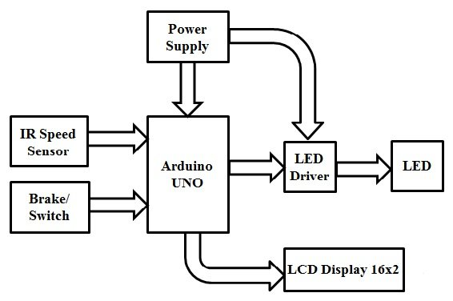
Fig 3.1 Transmitter Block Diagram.
3.2 Receiver section :
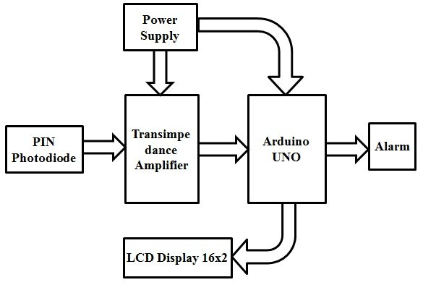
Fig 3.2 Receiver Block Diagram.

8
OBSTACLE AVOIDING CAR USING ARDUINO UNO

3.3 Power Supply Block Diagram :
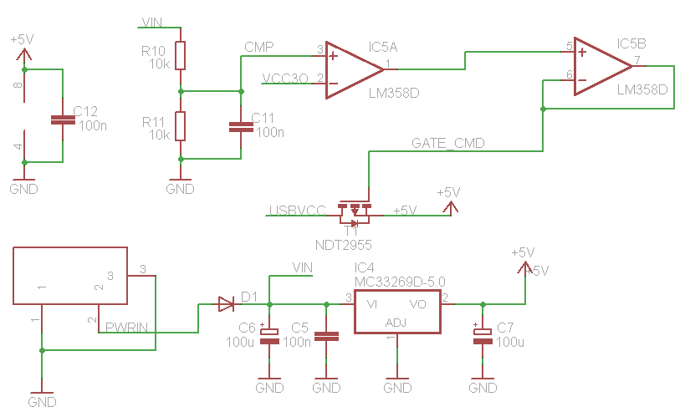
Fig: 3.3 Power Supply Block Diagram.
3.3.1 circuit Diagram :
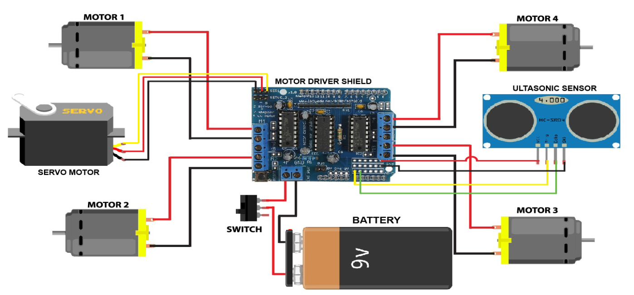
Fig: 3.4 Circuit Diagram.
9
OBSTACLE AVOIDING CAR USING ARDUINO UNO

CHAPTER - 4
HARDWARE
4.1 Motor Drive Shield (L293D) :
Turn on and turn off the speed of all motors and motor drivers. It has 4 output pins and 4 input pins To control two dc motors at the same time here two H-Ground motors is used which gives permissions to DC motors. L293d has H- bridge module which allows to control every direction of dc motors and speed. Here enables line is used to to control the motors independently and easily without any interruptions. Here TTL logic levels is designed to undertake heavy loads. L293d motor driver can handle the voltages from 5volts to 35volts easily and freely. To run the DC motors in any voltages motor driver can help to motors to convert low voltages to high voltages without any disturbances.
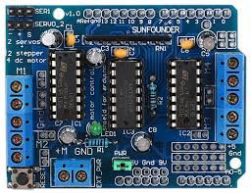
Fig:4.1 Motor driver shield

10
OBSTACLE AVOIDING CAR USING ARDUINO UNO

4.2 SG-90 Servo Motor:
- Standard servos are used to maintain a certain angle, not meant for full rotation
- Uses closed-loop feedback control
- Servos are used in applications requiring high torque, accurate rotation within a limited angle such as Robotic arms, valve control, rudder control etc.
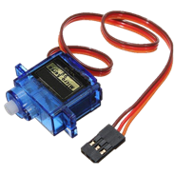
Fig: 4.2 Servo motor
4.3 Ultrasonic sensor:
Ultrasonic sensors measure distance by using ultrasonic waves. The sensor head emits an ultrasonic wave and receives the wave reflected back from the target. Ultrasonic Sensors measure the distance to the target by measuring the time between the emission and reception.
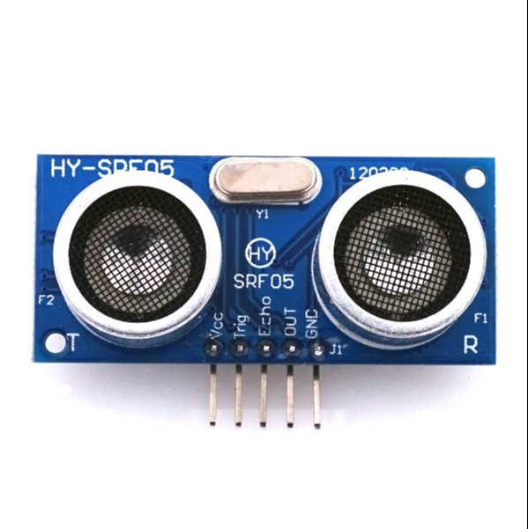

Fig: 4.3 Ultrasonic sensor
11
OBSTACLE AVOIDING CAR USING ARDUINO UNO

4.4 Switch:
In figure 4.4 A switch is used for turning on the power of the vehicle. It controls the battery connection of the vehicle.
A switch is an electrical component that can disconnect or connect the conducting path in an electrical circuit, interrupting the electric current or diverting it from one conductor to another.
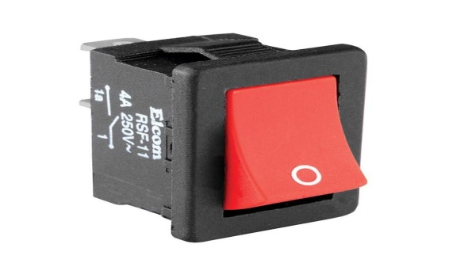
Fig: 4.4 Switch
4.5 Li-on Battery:
A battery is an energy source consisting of one or more electrochemical cells and terminals on both ends called an anode (-) and a cathode (+). Here for the project, a 9V battery has been used.
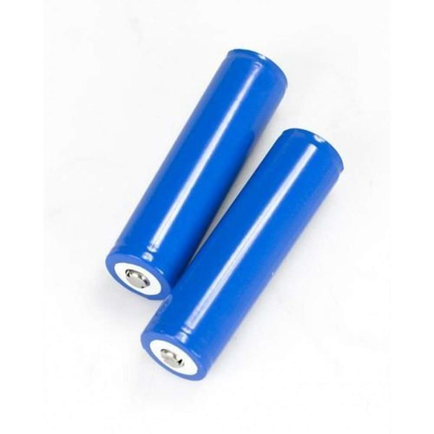
Fig: 4.5 Li-on Battery

12
OBSTACLE AVOIDING CAR USING ARDUINO UNO

4.6 TT Gear Motor:
A TT Gear Motor are an easy and inexpensive way to get your projects moving. It is a TT direct current gearbox motor with a 1:48 gear ratio, and comes with 2 X 200mm wires with 0.1” male connectors suitable for breadboard. Perfect for connection to a breadboard or terminal blocks.
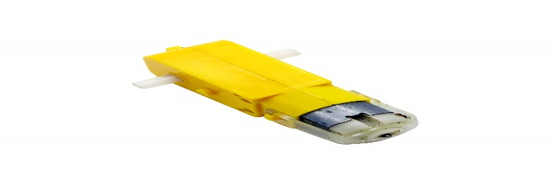

FIG:4.6 Gear motor
4.7Jumper wire:
A jump wire (also known as jumper, jumper wire, DuPont wire) is an electrical wire, or group of them in a cable, with a connector or pin at each end (or sometimes without them – simply "tinned"), which is normally used to interconnect the components of a breadboard or other prototype or test circuit, internally or with other equipment or components, without soldering.
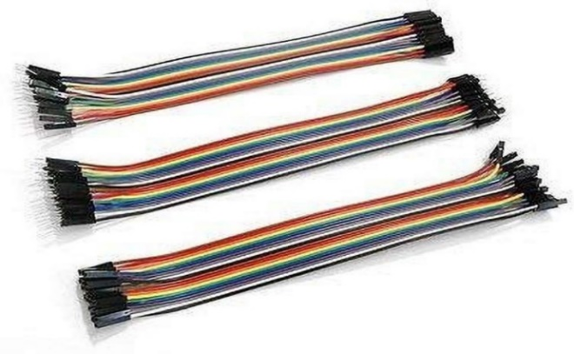
Fig: 4..7 Jumper Wires

13
OBSTACLE AVOIDING CAR USING ARDUINO UNO

CHAPTER - 5
SOFTWARE
5.1 Software explanation
WHAT IS ARDUINO UNO:
Arduino uno is a widely used microcontroller board that facilitates easy interaction with various electronics components, making it a popular choice for a range of projects, from simple prototypes to complex systems.
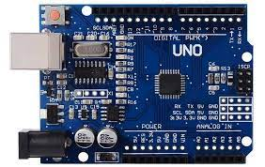
Fig: 5.1 Arduino UNO
ARDUINO IDE SOFTWARE:
The Arduino software, also known as the Arduino IDE (integrated development environment), is a cross-platform application that serves as a comprehensive programming tool for Arduino microcontrollers. It provides a user-friendly interface for writing, compling, and uploading code to Arduino boards. The software supports the Arduino programming language, which is based on C and C++, making It relatively easy for both beginners and experienced users to create and upload code to their Arduino
devices. Integrate various sensors, acutuators, and modules into projects. Its open-source nature has led to a vast community that contributes to its continuous development, making it a popular choice for hobbyists, students, and professionals alike in the realm of electronics and embedded systems

14
OBSTACLE AVOIDING CAR USING ARDUINO UNO

5.1.1 Set up the Software
- Click on the Arduino IDE icon on desktop
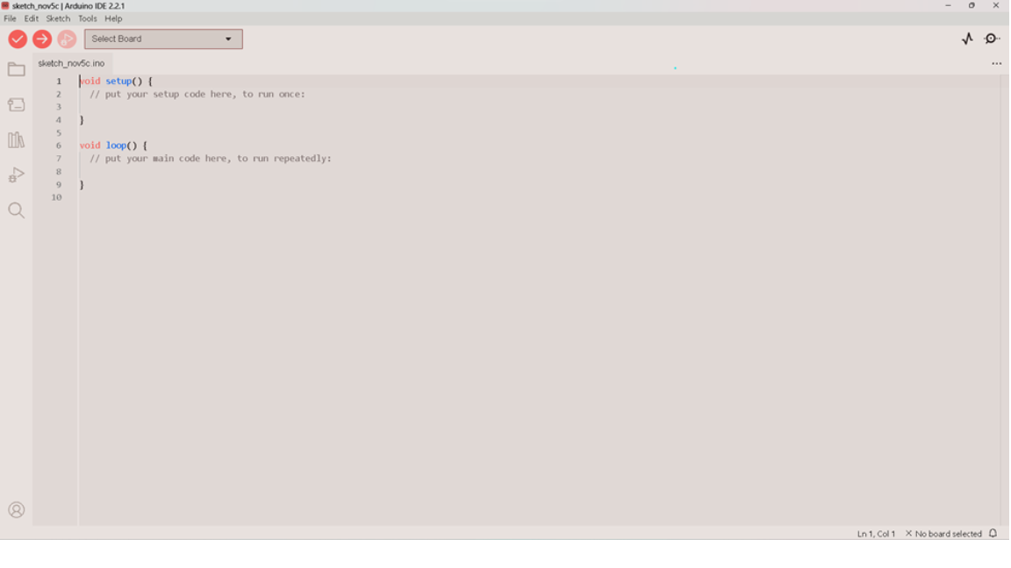
- The following fig will appear.

Fig: 5.1.1 Arduino IDE software in windows
- Clear the demo code.
- Then develop a program for obstacle detection and navigation as shown in following fig.

15
OBSTACLE AVOIDING CAR USING ARDUINO UNO

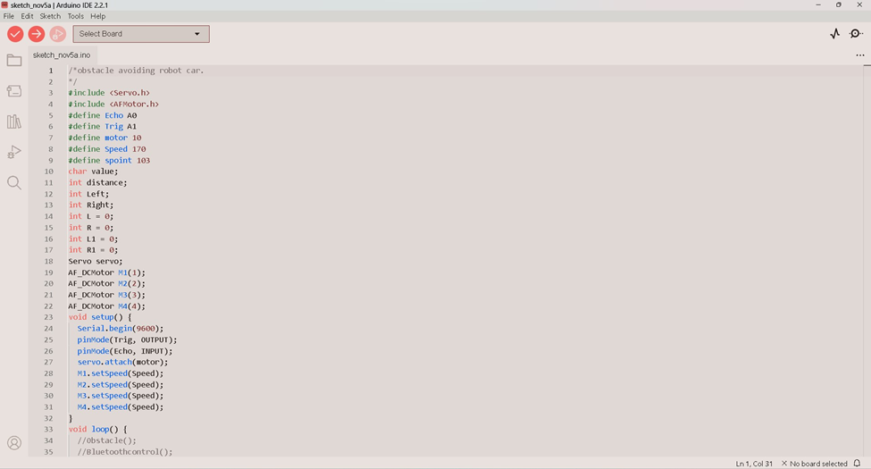
5.2.1 Installation of code:
Fig : 5.1.2 Arduino IDE project code
- Connect the Arduino via USB cable and Select Arduino uno board.
- Then verify and transfer the code to the Arduino uno.
- Then test and debug the car’s obstacle avoidance capabilities and address any issues.
- Then finalize the build and secure all connections and components firmly.

16
OBSTACLE AVOIDING CAR USING ARDUINO UNO

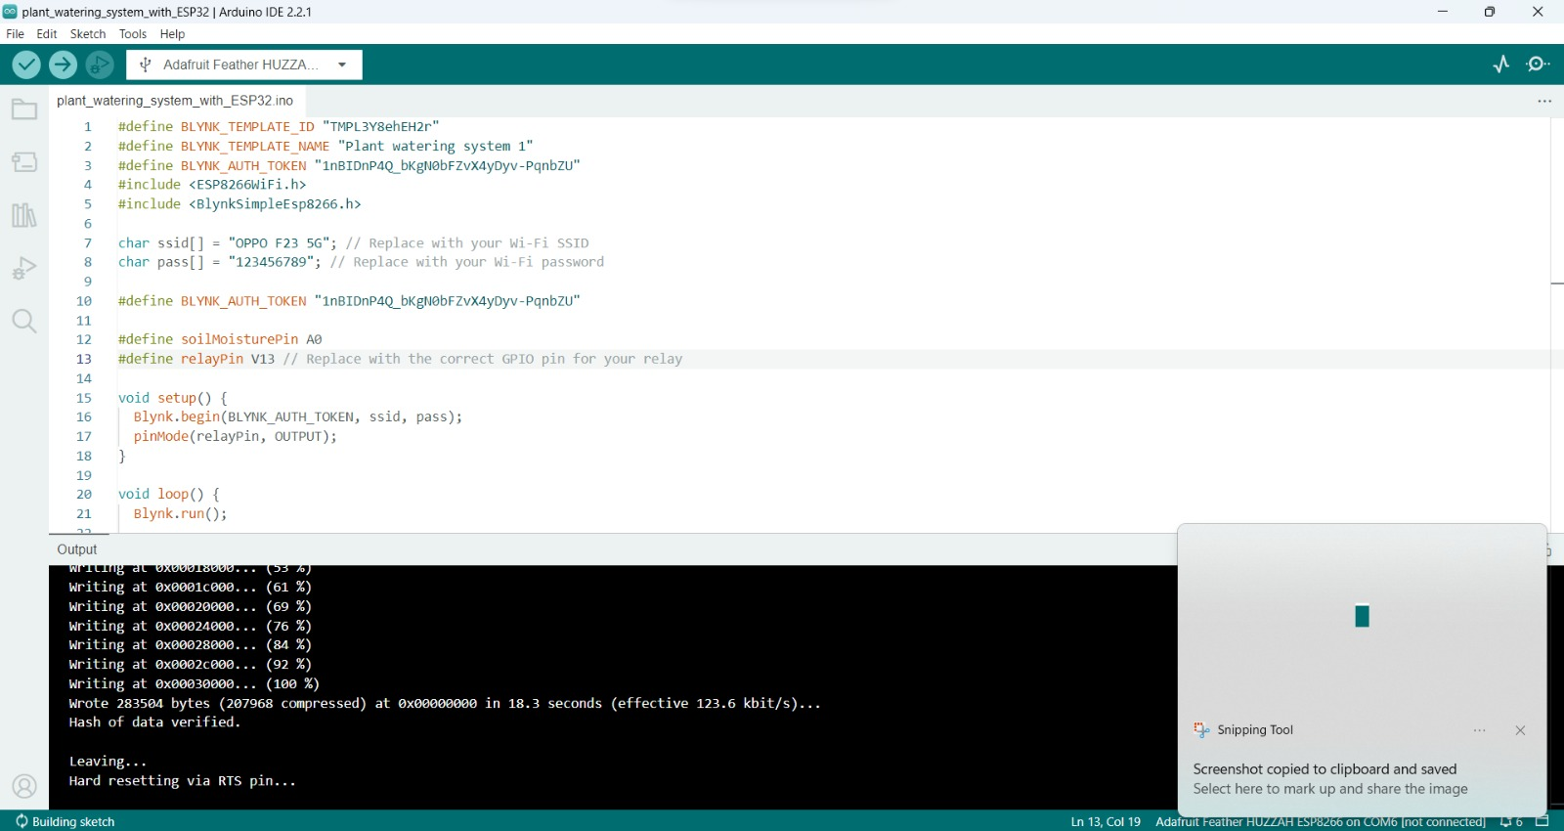
5.2.2 Run the code & Upload the code:

Fig: 5.1.3 Program output

17
OBSTACLE AVOIDING CAR USING ARDUINO UNO

CHAPTER - 6
SCHEMATIC DIAGRAM & WORKING PRINCIPAL
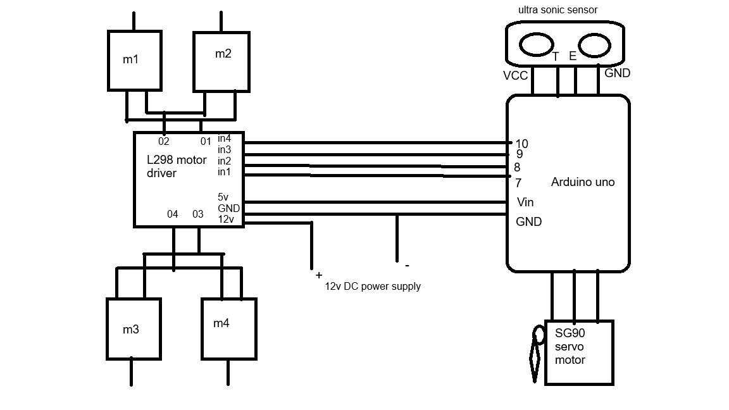
6.1 SCHEMATIC DIAGRAM :
Fig: 6.1 schematic diagram

18
OBSTACLE AVOIDING CAR USING ARDUINO UNO

6.2 Schematic Diagram Explanation :
The figure shows the schematic diagram of obstacle avoiding car.
- obstacle avoidance is the task of satisfying some control objective subject to non-intersection or non-collision position constraints.
- What is critical about obstacle avoidance concept in this area is the growing need of usage of unmanned aerial vehicles in urban areas for especially military applications where it can be very useful in city wars.
- With recent advanced in the autonomous vehicles sector, a good and dependable obstacle avoidance feature of a driverless platform is also required to have a robust obstacle detection module. [
- Reactive obstacle avoidance is a behaviour based control strategy in a robot. It is a task similar to the navigation problem and produces a collision free motion.
6.3 Working Principal :
The obstacle avoidance vehicle uses Ultrasonic sensors for its movements. A microcontroller of 8051 family is used to achieve the desired operation. The motors are connected through motor driver IC microcontroller. The ultrasonic sensor is attached in front of the vehicle.
The obstacle-avoiding car typically operates based on the following principles:
- Ultrasonic sensors: The car is equipped with ultrasonic sensors thar emit high-frequency sound waves and measures the time taken for the waves to bounce back after hitting an obstacle.
- Detection and Analysis: The car’s microcontroller processes the data received from the sensors to detect the presence and distance of obstacles.
- Decision Making: Based on the sensors data, the car’s control systems determine the best course of action to avoid the obstacle. This could involve stopping, slowing down, or steering away from the obstacle.

19
OBSTACLE AVOIDING CAR USING ARDUINO UNO

- Actuators and Motors: The control system then triggers the actuators and motors to implement the necessary action, such as turning the wheels or adjusting the speed, to avoid the obstacle.
- Continual Monitoring: The car continuously repeats this process, constantly scanning its surroundings and adjusting its path adjusting its path to ensure a safe and obstacle-free journey.

20
OBSTACLE AVOIDING CAR USING ARDUINO UNO

CHAPTER-7
RESULT
RESULT : The obstacle avoidance car using Arduino uno successfully detects obstacles using sensors and maneuvers to avoid them. The car is programmed to move forward until an obstacle is detected, after which it backs up, turns, and continues forward. The implementation involves integrating motors, sensors, and a microcontroller, with a code to control the car’s movements
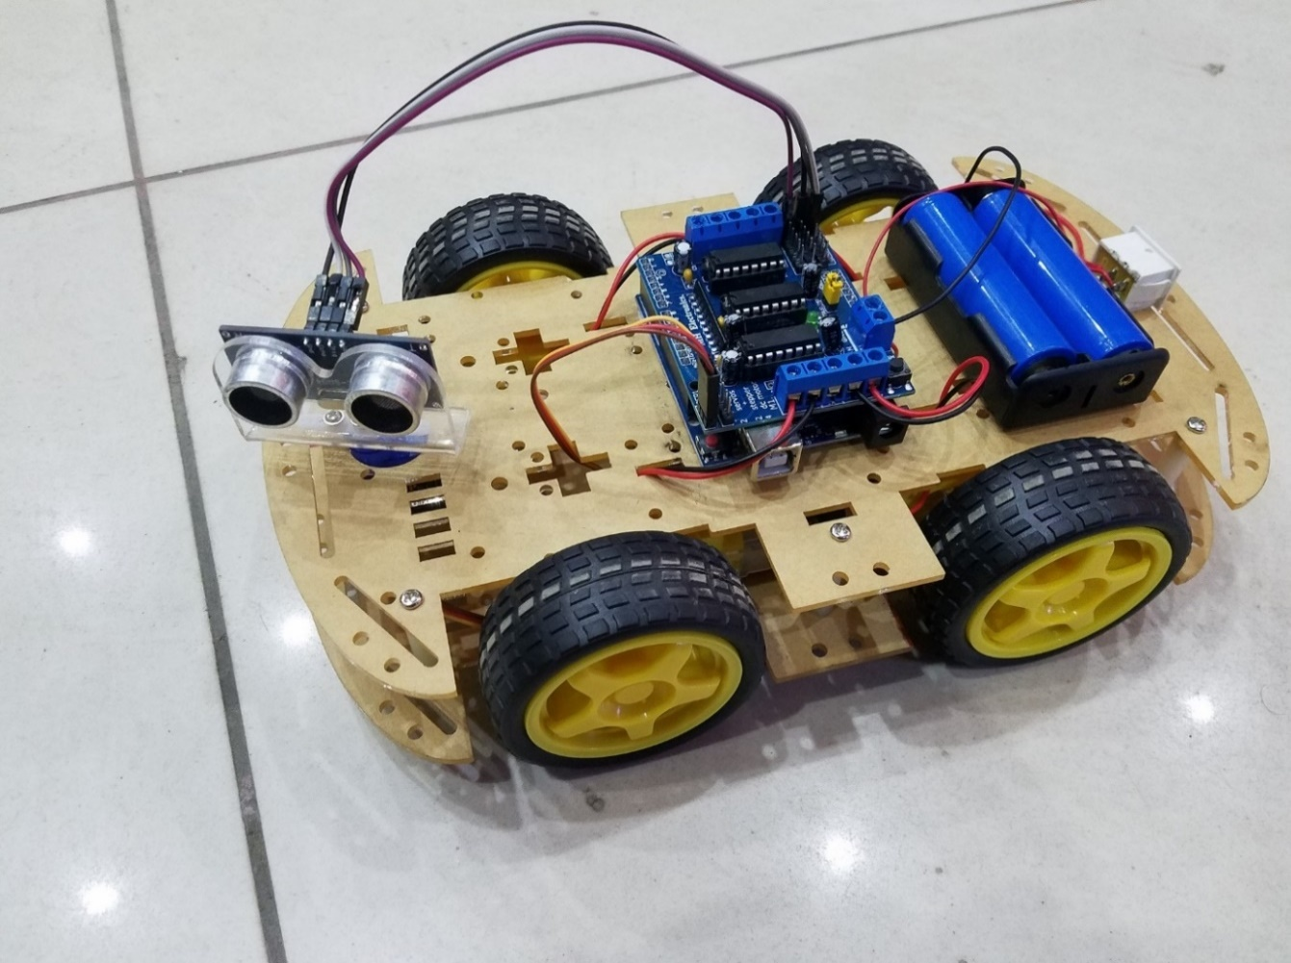
Fig: 7.0 obstacle avoidance car using Arduino uno

21
OBSTACLE AVOIDING CAR USING ARDUINO UNO

CHAPTER-8
ADVANTAGES AND APPLICATIONS
  - ADVANTAGES OF OBSTICALE AVOIDING CAR
- Reduce the likelihood of accidents and fatalities
- Bring more flexibility in varying environments
- Make them much more efficient
- Prevent the robots cause damage and casualties
- Allow robot to navigate in a unknown environment by avoiding collisions.
  - APPLICATIONS OF OBSTICALE AVOIDING CAR
- Keeping passengers safe
- Mobile navigation systems
- Military and law enforcement
- Search and rescue
- Forest conservation
- Automatic vacuum cleaning
- Factory and industry

22
OBSTACLE AVOIDING CAR USING ARDUINO UNO

CHAPTER-9
CONCLUTION
9.1 CONCLUSION :
The obstacle avoidance car project using Arduino UNO demonstrates an effective integration of hardware and software for autonomous navigation. By employing an ultrasonic sensor to detect obstacles in the car’s path, the Arduino UNO microcontroller processes the distance data and executes motor control commands accordingly. The implementation leverages the Adafruit motor shield library to facilities precise control of DC motors. When an obstacle is detected within a predefined range, the car intelligently maneuvers itself by either turning left or right to circumvent the obstacle and resume its forward motion. This project not only showcases the versatility of Arduino UNO in real-world applications but also underscores the importance of sensor integration for enhancing the autonomy of robotic systems

23
OBSTACLE AVOIDING CAR USING ARDUINO UNO

CHAPTER-10
FUTURE SCOPE
1. Using for educational, research, or industrial implementation.
2. Low cost implementation.
3. Customizable sensor integration.
4. Foundation for advanced prototyping.
5. Integration with lot and automation projects .
6. advanced driver assistance system

24
OBSTACLE AVOIDING CAR USING ARDUINO UNO

APPENDIX :
/*obstacle avoiding, Bluetooth control, voice control robot car.
https://srituhobby.com
*/
#include <Servo.h>
#include <AFMotor.h>
#define Echo A0
#define Trig A1
#define motor 10
#define Speed 170
#define spoint 103
char value;
int distance;
int Left;
int Right;
int L = 0;
int R = 0;
int L1 = 0;
int R1 = 0;
Servo servo;
AF_DCMotor M1(1);
AF_DCMotor M2(2);
AF_DCMotor M3(3);
AF_DCMotor M4(4);
void setup() {
Serial.begin(9600);
pinMode(Trig, OUTPUT);
pinMode(Echo, INPUT);
25
OBSTACLE AVOIDING CAR USING ARDUINO UNO

servo.attach(motor
M1.setSpeed(Speed);
M2.setSpeed(Speed);
M3.setSpeed(Speed);
M4.setSpeed(Speed);
}
void loop() {
//Obstacle();
//Bluetoothcontrol();
//voicecontrol();
}
void Bluetoothcontrol() {
if (Serial.available() > 0) {
value = Serial.read();
Serial.println(value);
}
if (value == 'F') {
forward();
} else if (value == 'B') {
backward();
} else if (value == 'L') {
left();
} else if (value == 'R') {
right();
} else if (value == 'S') {
Stop();
}
}
26
OBSTACLE AVOIDING CAR USING ARDUINO UNO

Void Obstacle(){
distance = ultrasonic();
if (distance <= 12) {
Stop();
backward();
delay(100);
Stop();
L = leftsee();
servo.write(spoint);
delay(800);
R = rightsee();
servo.write(spoint);
if (L < R) {
right();
delay(500);
Stop();
delay(200);
} else if (L > R) {
left();
delay(500);
Stop();
delay(200);
}
} else {
forward();
}
}
void voicecontrol(
27
OBSTACLE AVOIDING CAR USING ARDUINO UNO

if (Serial.available() > 0) {
value = Serial.read();
Serial.println(value);
if (value == '^') {
forward();
} else if (value == '-') {
backward();
} else if (value == '<') {
L = leftsee();
servo.write(spoint);
if (L >= 10 ) {
left();
delay(500);
Stop();
} else if (L < 10) {
Stop();
}
} else if (value == '>') {
R = rightsee();
servo.write(spoint);
if (R >= 10 ) {
right();
delay(500);
Stop();
} else if (R < 10) {
Stop();
}
} else if (value == '*') {
28
OBSTACLE AVOIDING CAR USING ARDUINO UNO

Stop();
}
}
}
// Ultrasonic sensor distance reading function
int ultrasonic() {
digitalWrite(Trig, LOW);
delayMicroseconds(4);
digitalWrite(Trig, HIGH);
delayMicroseconds(10);
digitalWrite(Trig, LOW);
long t = pulseIn(Echo, HIGH);
long cm = t / 29 / 2; //time convert distance
return cm;
}
void forward() {
M1.run(FORWARD);
M2.run(FORWARD);
M3.run(FORWARD);
M4.run(FORWARD);
}
void backward() {
M1.run(BACKWARD);
M2.run(BACKWARD);
M3.run(BACKWARD);
M4.run(BACKWARD);
}
void right() {
29
OBSTACLE AVOIDING CAR USING ARDUINO UNO

M1.run(BACKWARD);
M2.run(BACKWARD);
M3.run(FORWARD);
M4.run(FORWARD);
}
void left() {
M1.run(FORWARD);
M2.run(FORWARD);
M3.run(BACKWARD);
M4.run(BACKWARD);
}
void Stop() {
M1.run(RELEASE);
M2.run(RELEASE);
M3.run(RELEASE);
M4.run(RELEASE);
}
int rightsee() {
servo.write(20);
delay(800);
Left = ultrasonic();
return Left;
}
int leftsee() {
servo.write(180);
delay(800);
Right = ultrasonic();
return Right;
30
OBSTACLE AVOIDING CAR USING ARDUINO UNO

REFERENCE:
- https://www.arduino.cc/en/software
- https://learn.adafruit.com/
- https://create.arduino.cc/projecthub
- https://github.com/
- https://chat.openai.com/

31

